به نام خدا

گزارش تمرین شماره 1 شبیه‌سازی **JMT**

حسام تاج‌بخش

93725102

استاد: دکتر آنالویی

زمستان 93

Part A:

Service demand of transaction at each resource:

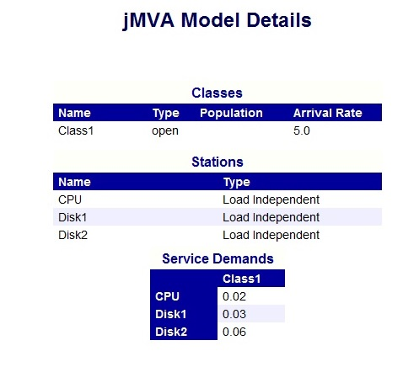

System throughput and throughput of each resource:

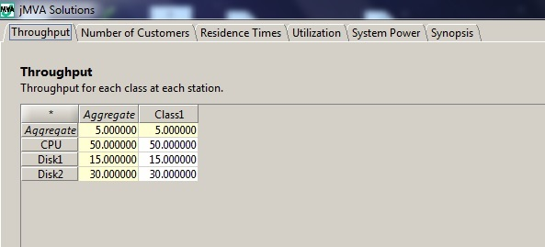

Utilization of each resource:

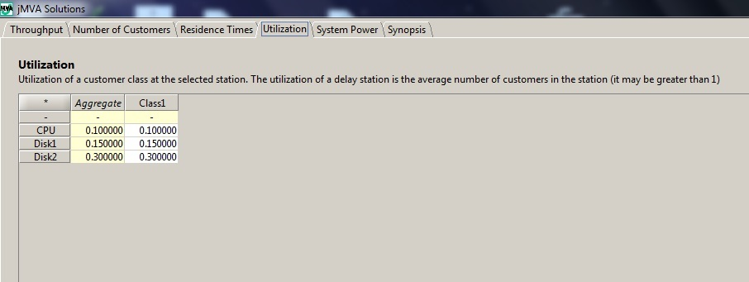

Residence time of transaction at each resource and system response time (aggregate response time) :

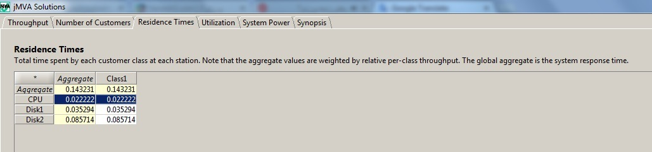

Number of transaction at system and each resource:

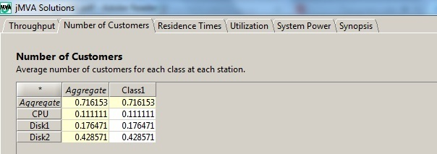

Part B:

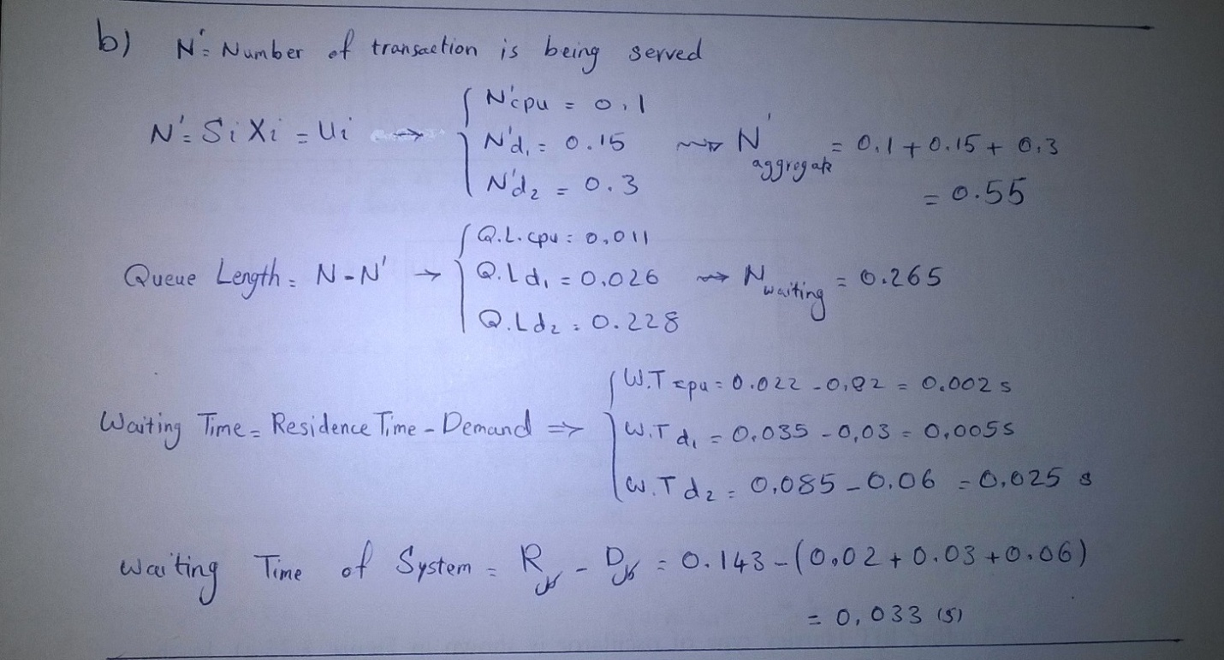

Part C:

Scenario 1:

Service Demand:No change in service demand. Similar to Part A.



System Throughput and Throughput of each resource:

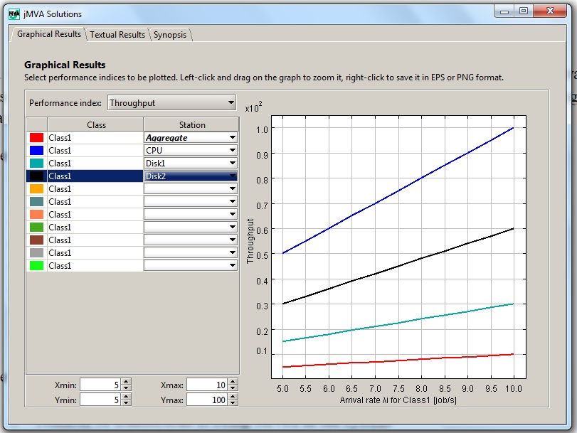

Utilization of each resource:

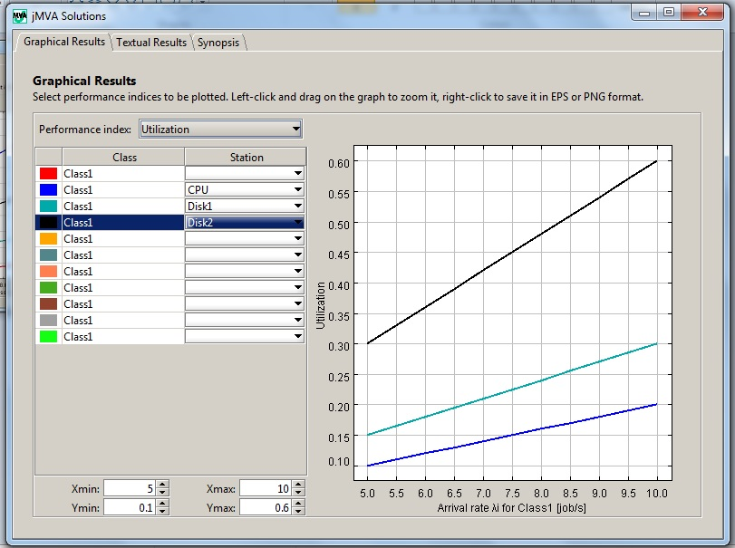

Residence time of transaction at each resource:

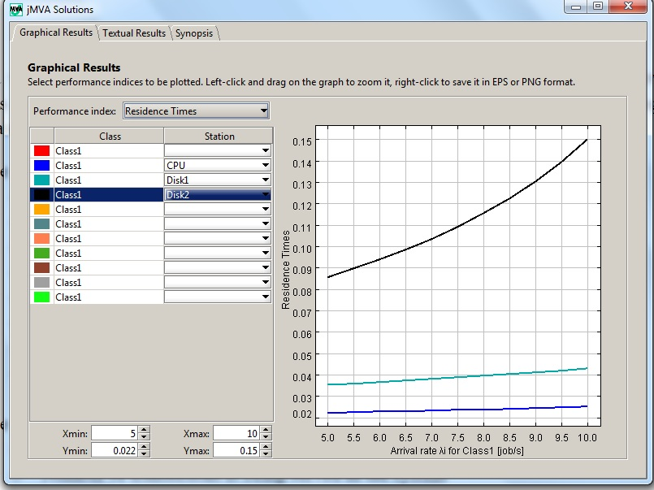

System response time:

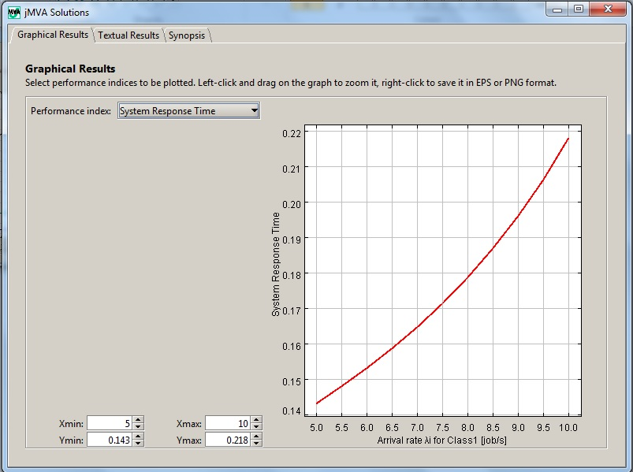

Number of transaction at system:

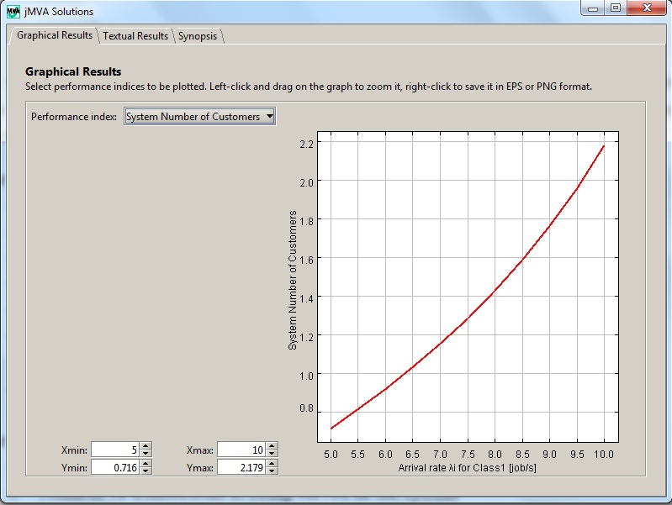

Number of transaction at each resource:

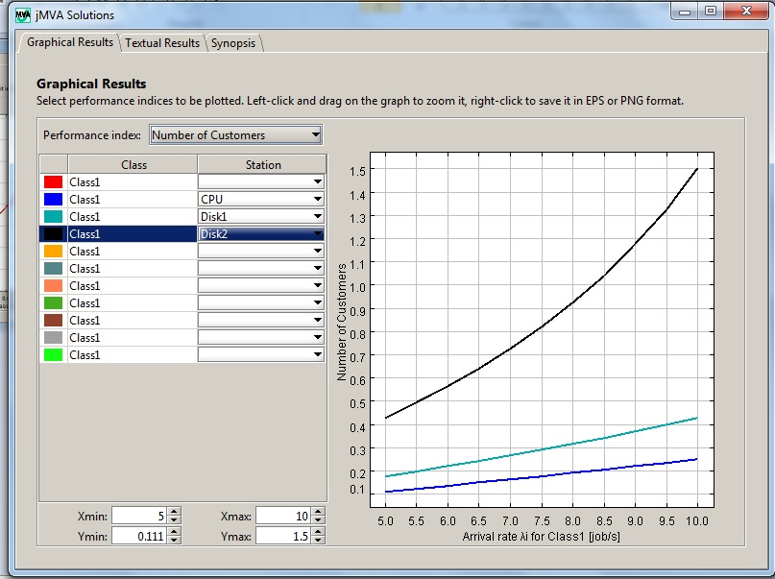

Scenario 2:

Disk2 is replaced by one that is three times faster, means new demand is one third.

Response Time:

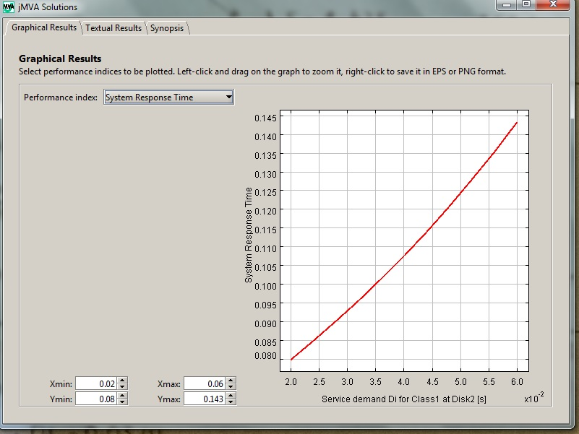

Scenario 3:

Service demand of each resource:

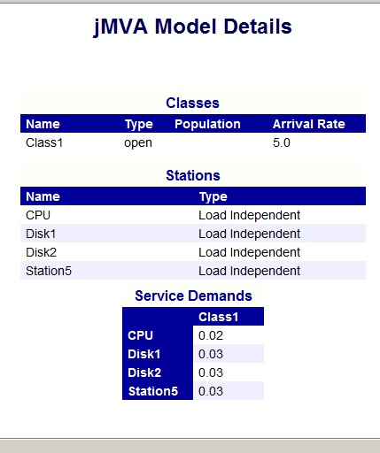

Residence Time (Aggregate response time) :

